**Project Scheduling:**

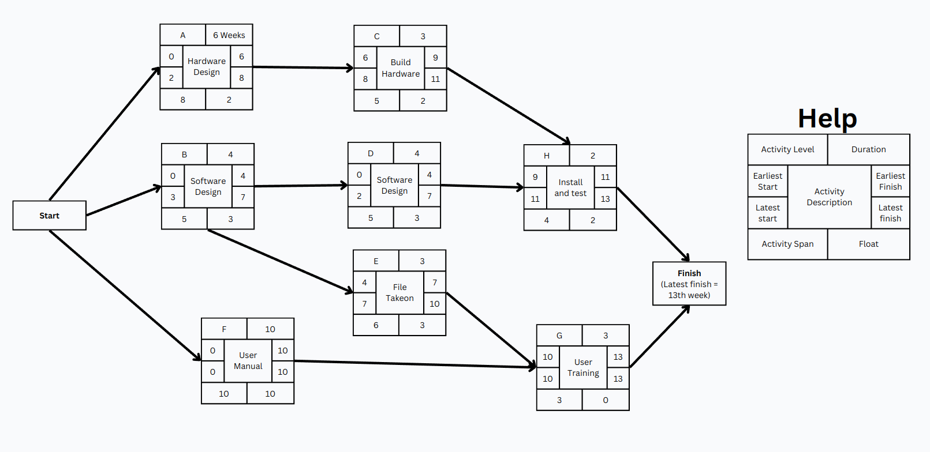

Constraints: Node H cannot start unless B and C are finished

|  |  |  |
| --- | --- | --- |
| **Activity** | **Duration (wks)** | **Preference** |
| 1. **Hardware Selection** | **6** |  |
| 1. **Software Design** | **4** |  |
| 1. **Build Hardware** | **3** | **A** |
| 1. **Code and test software** | **4** | **B** |
| 1. **File take-on** | **3** | **B** |
| 1. **Write user manual** | **10** |  |
| 1. **User training** | **3** | **E, F** |
| 1. **Install and test software** | **2** | **C, D** |

**Project Specification**

**CRITICAL PATH METHOD**

The critical path method is concerned with two primary objectives:

1. Planning the project in such a way that it is completed as quickly as possible, and
2. Identifying those activities where a delay in their execution is likely to affect the overall end date of the project

**The network is analysed**

1. **Forward Pass**: to calculate the earliest dates at which activities may commence and the project be completed
2. **Backward Pass:** to calculate the latest start dates for activities and the **Critical path**

**Assumption:** The latest finish date for the project is same as the earliest finish date, that is, we wish to complete the project as early as possible

**Activity Span:** L.F – E.S

**Float =** L.S – E.S = L.F – E.F

**Float** is a measure of how much the start or completion of an activity may be delayed without affecting the end date of the project.

Any activity with a float of zero is critical in the sense that any delay in carrying out the activity will delay the completion date of the project as a whole

|

V

**Project Specification:** There will always be at least one path through the network joining those crucial activities, this is the CRITICAL PATH

**Uncertainty in Task duration**

**PERT(**program evaluation and review technique) provides a method for estimating the probability of meeting with missing target dates

Activity Duration (wks)

|  |  |  |  |
| --- | --- | --- | --- |
| **Activity** | Optimistic(a) | Most likely (m) | Pessimistic (b) |
| **A** | 5 | 6 | 8 |
| **B** | 3 | 4 | 5 |
| **C** | 2 | 3 | 3 |
| **D** | 3.5 | 4 | 5 |
| **E** | 1 | 3 | 4 |
| **F** | 8 | 10 | 15 |
| **G** | 2 | 3 | 4 |
| **H** | 2 | 2 | 2.5 |

Expected duration:

$$t_{e}= \frac{a+4n+b}{6}$$

PERT event labeling connection

|  |  |
| --- | --- |
| Event Number | Target Date |
| Expected date | Standard deviation |

$$t_{e}=\frac{5+24+8}{6}=\frac{37}{6}=6.17$$

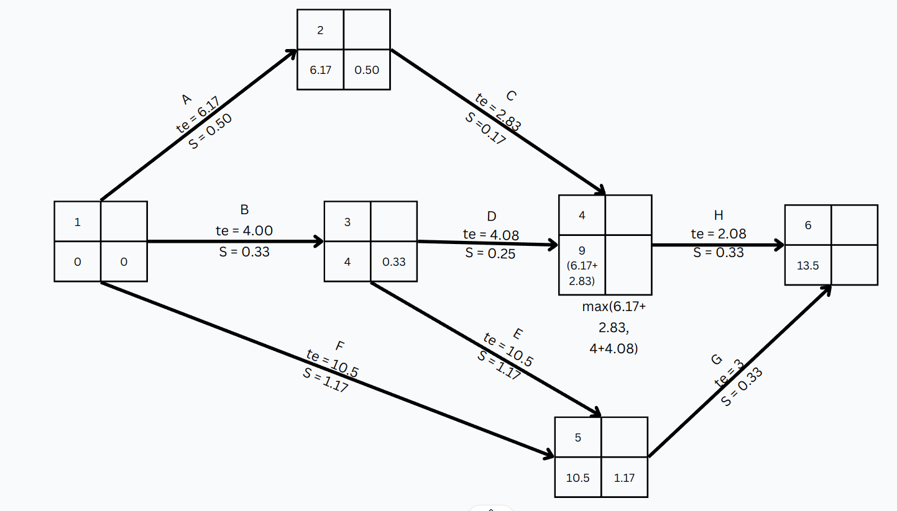

**Standard deviation for an activity**

$$S= \frac{b-a}{a}$$

|  |  |
| --- | --- |
| **Event** | **Std dev** |
| B | 0.33 |
| E | 0.5 |

B + E = $\sqrt{{0.33}^{2}+{05}^{2}}=0.6$